**Practical 2**

**Aim: If...else and elif**

1. **Write a program to check given number is even or odd**

**Code:**

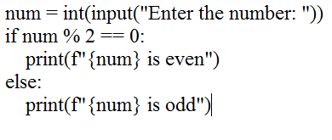

**Output:**

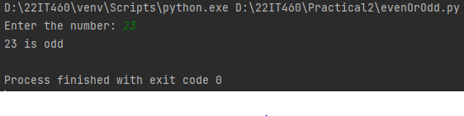

1. **Write a program to take sentence from user and count no of digits, letters, uppercase letters, lowercase letters**

**Code:**

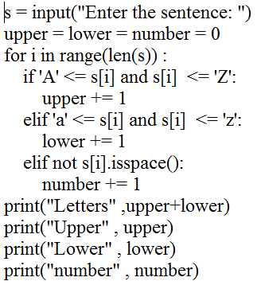

**Output:**

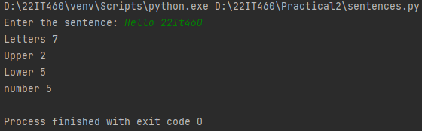

1. **Write a program to find maximum number from three number**

**Code:**

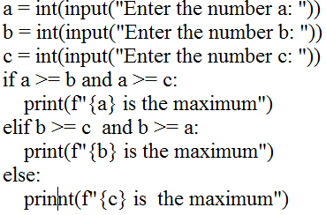

**Output:**

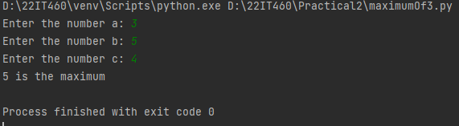

1. **Write a program to calculate the grade based on the percentage score**

**Code:**

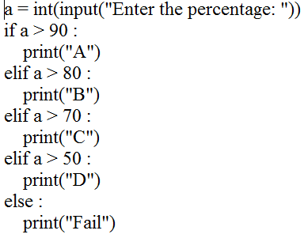

**Output:**

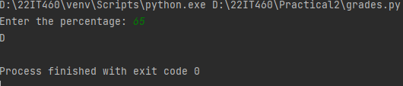

1. **Write a program to check if the input year is leap year or not.**

**Code:**

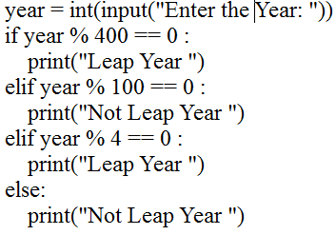

**Output:**

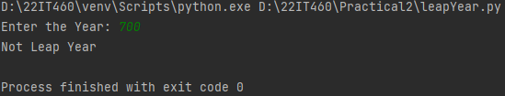

1. **Write a program to solve a quadratic equation ax2+bx+c=0**

**Code:**

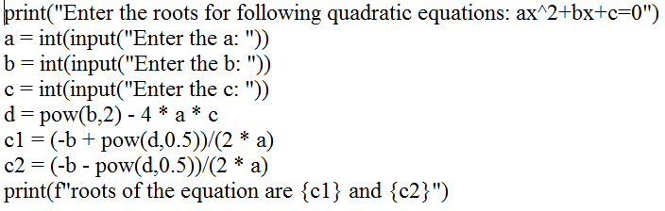

**Output:**

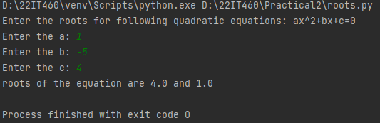

1. **Write a program to implement a two player rock-paper-scissors game with input validation**

**Code:**

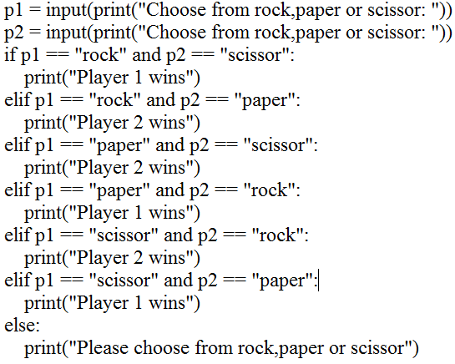

**Output:**

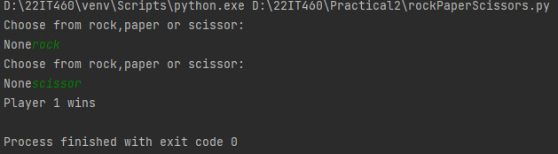

1. **Write a program that takes the working hours and wages of 5 employee and calculate salary of the employee**

**Code:**

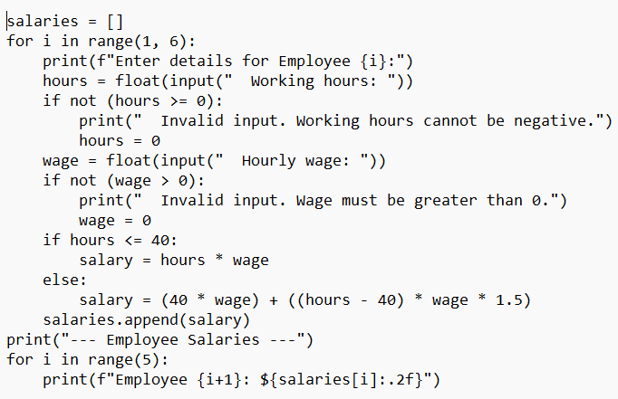

**Output:**

